Current Process-

Customer creates order/s

To generate xml file and upload to S3 I run rake task xmlord

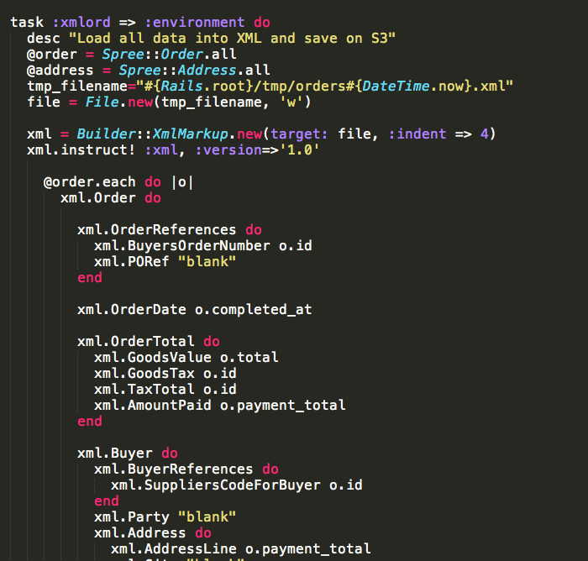

Right now when I run this task it only seems to generate the latest order as an xml and upload it, so if I had 5 orders only one would generate and upload.

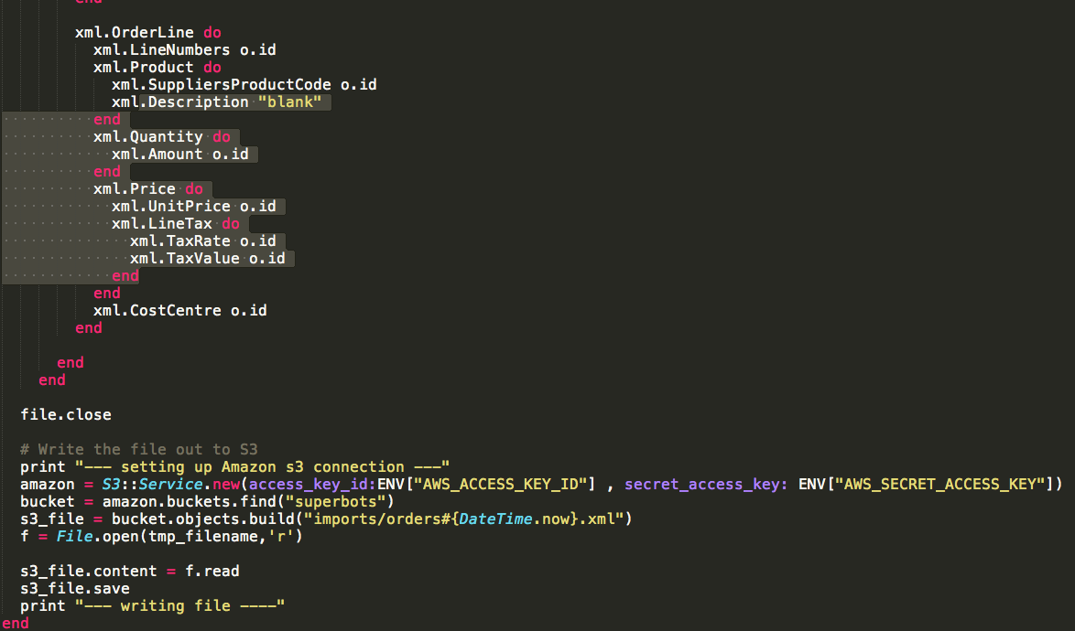

I need a way to export every order that’s created as xml and upload them to S3, with the timestamp that I already have implemented when an xml file is made.

On the heroku side I need this to run every half an hour and collect all (if any) of these xml files and upload them to S3.

Files should not be duplicated and uploaded, so maybe move the xml files to a different directory after they have been uploaded.

Maybe I’m not thinking about the process I’m trying to apply correctly if you can think of a more logical way for this to work that would be great.